Automotive LiDAR Evaluation Unit

Version 1.4 | 2018-10-15

Table of contents

Introduction 3

AWL-7 3

AWL-16 4

General Specifications 4

Environment 4

Lasers 4

Input/Output 4

Options 4

EV-Unit Housing 5

USB to CAN Adapter 6

Optional Integrated Camera 6

Installation steps 7

Install the EV-Unit Demo software 7

Connect the EV-Unit CAN Adapter 7

Connect the optional camera Port (if provided) 7

Configure applications for the KVaser Leaf Can Adapter 8

Install the drivers for the KVaser Leaf CAN Adapter 8

Determine the KVaser channel 9

Edit the configuration file for the KVaser Leaf CAN Adapter 9

Configure applications for the EasySync CAN adapter 9

Determine the port 10

Configure EasySync Serial port 11

Edit the configuration file 13

Install the camera drivers 13

Start the EV-Unit Application 18

Calibration of the EV-Unit 19

Introduction 19

Calibration types 19

Calibration procedure 20

Material Required 20

Setting up the mask sheet 21

Calibration steps 24

# Introduction

The Phantom Intelligence EV-Units (Automotive LiDAR Evaluation Units) are a laser based obstacle detection devices that provides precise estimation of the distance and relative velocity of objects that are in its field of view (FOV). There are currently two variations of the EV-Unit platform, the AWL-7 and AWL-16.

This document will guide you through the installation of the hardware and configuration of the demonstration software that is provided with the EV-Units.

## AWL-7

**AWL-7** is a 7 pixel LiDAR designed especially for mounting between the windshield and rear-view mirror.

Combined in a single unit, it is both a long-range, narrow field of view sensor for high-speed collision warning and a medium-range, wide field of view sensor capable of detecting small obstacles right in front of the vehicle.

* Twin receiver optics
* Two fields of view:
  + 150x50 – 3 pixels narrow FOV
  + 300x80 - 4 pixels wide FOV

 

## AWL-16

**AWL-16** is an 8x2 arrayed LiDAR. With its symmetrical configuration, it is suitable for a wide variety of settings. Its high pixel density provides lateral precision.

* Single receiver optics
* Symmetrical 8 x 2 optical configuration
* Two-line field of view:
  + 250x1.50
  + 1.50 spacing between lines.

 

## General Specifications

### Environment

* Operating temperature: -40O to +85o C
* Power supply: 10 to 17V
* Power consumption: < 10W
* Dimensions: 155x75x45 mm

### Lasers

* Output power: 70W
* Wavelength: 905nm
* Laser pulse length: < 30ns
* Laser frequency: 30KHz

### Input/Output

* Single Sealed CAN Connector

### Options

* Multiple laser control (1 or 2 laser sources)
* Configurable Fields of view
* Optional integrated camera
* Multiple mount options
  + Windshield housing
  + IP-67 exterior body

Additional features can be integrated

## EV-Unit Housing

The EV-Unit module houses:

* 2 laser emitters (1 per FOV)
* 2 distinct receiver optics
* 1 camera (optional)

The following pictures show the layout of the components in the housing (the front window is shown in transparent for illustration purposes).

|  |
| --- |
| Emitters  Camera  Receivers |
| Figure 1: Housing - Front view |
| Connector |
| Figure 2: Housing - Rear view |

## USB to CAN Adapter

The EV-Unit is provided with a CAN to USB adapter. Depending on your package configuration, the CAN to USB Adapter can be either of the following:

* Kvaser Leaf Light HS (or HS V2)
  + The Kvaser Leaf interface is a robust and compact CAN to USB Adapter. Software drivers for the Kvaser are available for Windows and Linus operating Systems. The drivers provide a simple programming interface and allow the support of multiple devices.
  + Windows drivers are provided with the installation kit. They are located in the *Kvaser* subdirectory of the installation folders. Other drivers and additional software can be downloaded from:
    - <http://www.kvaser.com/downloads/>
  + The Kvaser Leaf drivers are the default CAN to USB interfaces provided by Phantom Intelligence in its Evaluation Kits.
* EasySync USB-F-7x01
  + The EasySync is a simple CAN to USB Adapter that is “seen” by the applications as a straightforward serial port. The EasySync adapter is provided upon request to clients that need a straightforward interface, without any complex drivers. This may be the case, for example, when interfacing the EV-Unit with a microcontroller based processor.
  + On some operating systems, the EasySync interface may require “tuning” of the serial ports operating parameters (such as buffer size, latency) for optimal performance.

## Optional Integrated Camera

The EV-Unit is provided with an optional USB Camera (when EV-1-C option is specified).

The camera requires the installation of the appropriate camera driver software.

# Installation steps

## Install the EV-Unit Demo software

Double-click on the file named “*AWLQtDemoSetup.msi*” to start installation of the EV-Unit Demo software.

This package will install the EV-Unit Demo Software on your computer.

By default, the software will be installed to C:\Aerostar\Aerostar EV-UnitQtDemo.

## Connect the EV-Unit CAN Adapter

Plug in the EV-Unit CAN converter assembly to the back of the EV-Unit.

Plug the USB end of the assembly to a USB port on your computer.

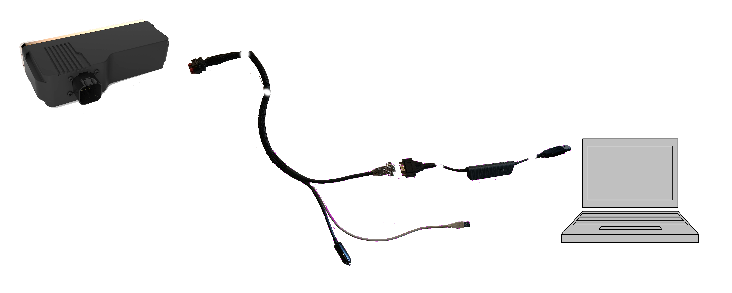

Optional Camera USB

Can to USB

Figure 3: EV-Unit - Wiring to the computer - (Kvaser Leaf CAN to USB Adapter shown)

Depending on the CAN to USB interface supplied, follow the instructions to install the interface driver and configure the application.

* For the Kvaser Leaf CAN to USB Camera adapters, follow the instructions in section “*Configure applications for the KVaser Leaf Can Adapter*”, below;
* For the EasySync CAN to USB asdapter, follow the instructions in section “*Configure applications for the EasySync CAN adapter*”, below.

## Connect the optional camera Port (if provided)

Connect the optional USB camera port to yourt computer.

Install and configure the Ximea Camera drivers according to the instructions of section “*Install the camera drivers*”, below.

## Configure applications for the KVaser Leaf Can Adapter

Follow these instructions if your EV-Kit was provided with the KVaser Leaf CAN to USB Adapter.

### Install the drivers for the KVaser Leaf CAN Adapter

Users of Evaluation Kits based on the Kvaser Leaf CAN to USB Interface should install the provided Kvaser drivers.

The Kvaser Leaf Drivers for Windows, and associated software are provided in the “Kvaser” subdirectory of the installation kit.

To install the drivers, simply double-click on:

*Kvaser\kvaser_drivers_setup.exe*

and follow instructions*.*

Additional programs are provided in the KVaser subdirectory and are provided for monitoring and debug purposes. See the *kvaser_leaf_userguide.pdf* document for additional information.

### Determine the KVaser channel

Use the Kvaser Hardware configuration application to determine the CAN Channel used for the EV-Unit Device. Note the channel number. On installations where the EV-Unit is the only device usingt the KVaser hardware, the Channel is 0 and should not be changed.

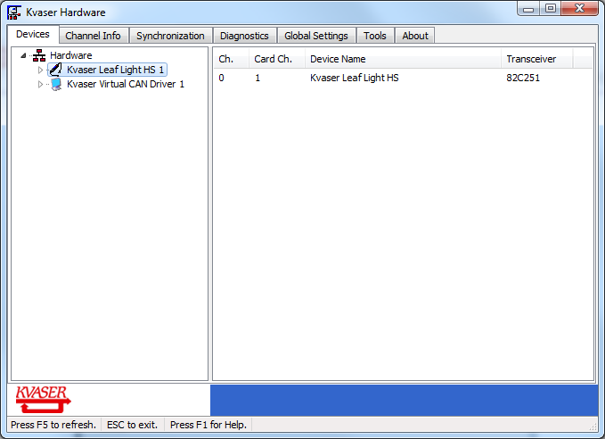

Figure 4: The Kvaser Hardware Configuration application

### Edit the configuration file for the KVaser Leaf CAN Adapter

Open the EV-UnitQtDemo configuration file (*EV-UnitDemoSettings.xml*):

* Find the line that starts with :  
   <receiverType>….. </receiverType>  
  And type in “KVaserLeaf” as the receiver Type. Use of the proper uppercase / lowercase is required.  
  The resulting line should read:  
   <receiverType>KVaserLeaf</receiverType>
* Find the line that reads:  
  <kvaserChannel>0</kvaserChannel>  
  Replace “0” by the channel number you have found in the previous step

## Configure applications for the EasySync CAN adapter

Follow these instructions if your EV-Kit was supplied with an EasySync CAN to USB adapter. The EasySync interface does not require the installation of specific drivers, as the device is seen as a “Virtual Serial Port” under Windows. However, the software must be configured to recognize the serial port that will be assigned by Windows on connection of the device.

### Determine the port

In Control Panel / Device manager, find the serial port identified under the name “USB-F-7x01 CAN Plus Com Port (COMxx)”.

Note the number of the COM port in parentheses the device name (“COM28”) in the example below:

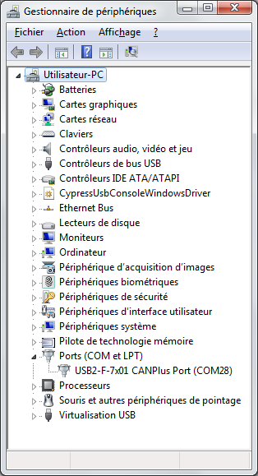

Figure 5: Determine the serial commmunications port

### Configure EasySync Serial port

The EV-Unit device operates at 1Mbps. Under the Windows serial communications port settings, this maps to a 921600 bps baud rate.

In Control Panel / Device manager, find the serial port identified under the name “USB-F-7x01 CAN Plus Com Port (COMxx)”. Right click on the port and select “*Properties*” to insure that the port’s baud rate is set as the maximum possible. The Windows virtual port driver will adjust for optimal performance.

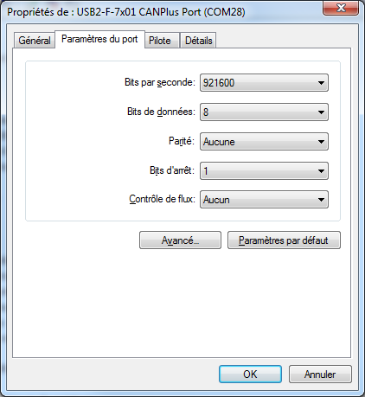

Figure 6: Setting the baud rate

To insure optimal performance and response time, it is recommended that you adjust the following parameters of the “Advanced” section of the communications parameters (see Figure 7: Setting the communications buffer sizes and latency, below):

* Latency time (should be set to 3ms)
* Minimum delay before write (0 ms)
* Minimum delay before read (0ms)
* USB Frame Length
  + Read (1024 bytes)
  + Write (2048 bytes)

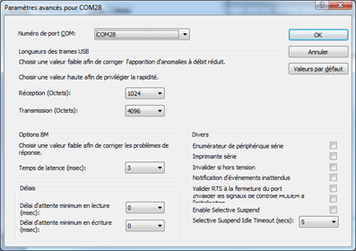

Figure 7: Setting the communications buffer sizes and latency

Also uncheck the “Serial Enumerator” option (circled in red Figure 7: Setting the communications buffer sizes and latency, above).

*When the “Serial Enumerator” option is checked, the device driver defaults to query an attached device to find out whether it is a mouse or modem, consistent with native COM port operation. Some serial peripherals constantly send short packets of data, causing the host system to “think” a mouse or modem has been attached. These short packets will interfere with normal mouse operation causing the pointer to jump around the screen.*

If required, the assigned COM port number can be “forced” to a value different than the default assigned value in the “COM Port Number” Combo Box located at the upper left of the Advanced Settings.

### Edit the configuration file

Open the EV-UnitQtDemo configuration file (*EV-UnitDemoSettings.xml*):

* Find the line that starts with :  
   <receiverType>….. </receiverType>  
  And type in “EasySyncCAN” as the receiver Type. Use of the proper uppercase / lowercase is required.  
  The resulting line should read:  
   <receiverType>EasySyncCAN</receiverType>

* Find the line that reads:  
  <commPort>COM28</commPort>  
  Replace “COM28” by the name of the COM port you have found (or assigned) in the previous step.

## Install the camera drivers

The Camera Drivers for Windows, and associated software are provided in the “Camera” subdirectory of the installation kit. The camera used is a Ximea MU9PC-MH subminiature USB camera.

To install the drivers:

1. Be sure that You have Administrator privileges

Click right mouse button on the downloaded file and use "Run as administrator"

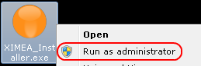

1. read the License Agreement and Accept it.

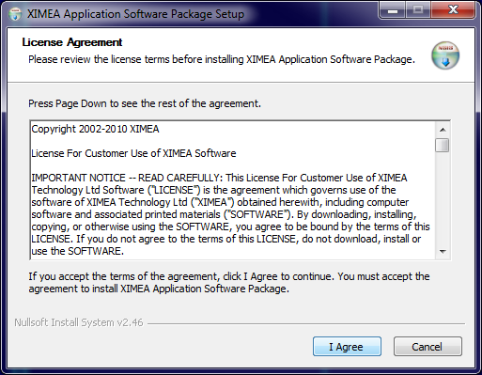

1. Select the Software components you want to install. You can uncheck the components you don't want to install, but it is recommended to leave them all checked.

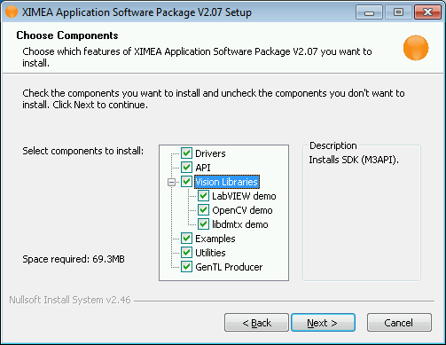

1. Specify the install location - you can leave the default location or change it to your desired location.

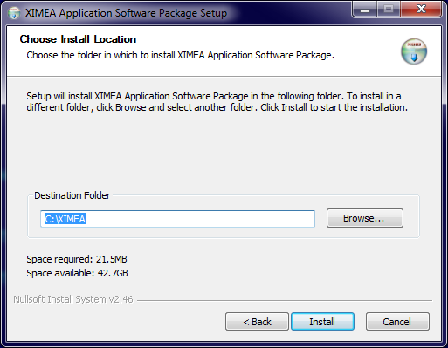

1. Now the XIMEA API Software Package should start copying files, updating System Variables and installing drivers if necessary.

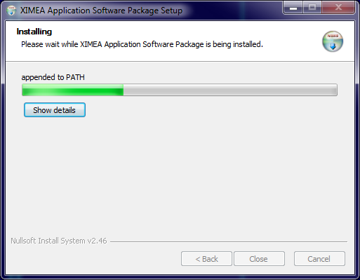

1. Installation is completed.

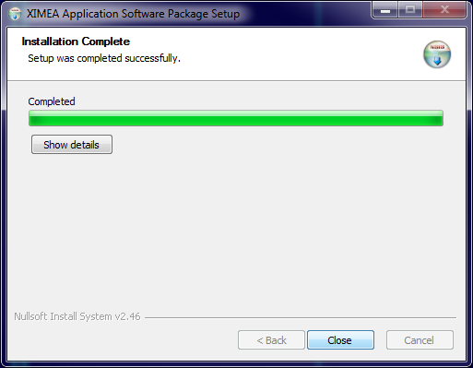

1. Changes to System Environment Variables may require system reboot. If you want to reboot immediately select 'Reboot Now' option, otherwise select 'I want to manually reboot later'.

# Start the EV-Unit Application

To be detailed.

# Calibration of the EV-Unit

## Introduction

The calibration procedure resets some of the internal references in the EV-Units. It is used to compensate for variations in the performance of the system that can be caused by a number of factors, including a change in the performance of the components due to aging.

Your EV-Unit has been factory calibrated for “Open Air” operation (see below).

The calibration should be performed for every change in the operation environment of the unit.

## Calibration types

For experimental purposes, the calibration procedure can be used in three different circumstances:

* Calibrating to compensate for “internal” factors (“Internal” calibration)
  + The internal calibration is the type of calibration performed at the factory. It stores basic operating parameters of the unit (electrical noise measurements, etc.).
  + It is recommended to perform an internal calibration when internal; parameters are changed that may affect the response of the sensor electronics. Most alterations of the FPGA, ADC or GPIO registers justify a recalibration.
  + Warning: Internal calibration should not be performed before the unit is placed behind the windshield, as internal reflections of the glass can cause unwanted effects (see “ambient calibration”, below).
* Calibrating in a behind the windshield configuration (“Windshield” calibration)
  + The *windshield* calibration procedure is similar to the *internal* calibration procedure. The only difference is that the calibration must take into account the effects of the internal reflections within the windshield glass.
* Calibrating for static background removal (“Background” calibration)
  + In some test circumstances where the EV-Unit is static (not moving) and there are static objects causing background clutter, it may be desirable to remove the detections caused by these background clutter elements. The background calibration will compensate for the presence of some of the background elements.
  + Warning: Background calibration may reduce the precision of measurements produced by the EV-Unit. The variation in the precision of the measurement is dependent on the nature of background clutter and of the moving obstacles.
  + Background calibration can be used in presence detection scenarios, only when the EV-Unit is in a fixed position and when very high precision distance and speed measurements are not required.

Typically, in an Open Air configuration (no window or enclosure around the EV-Unit), an Internal Calibration is the recommended practice.

In the case where the unit is used behind a windshield, an ambient calibration should be performed.

## Calibration procedure

### Material Required

To perform the calibration, you will need a small “mask” sheet, used to cover the optics of the EV-Unit receiver. The purpose of the mask sheet is to block incoming or outgoing visible or infrared light coming from the emitter or received at the receiver section. The mask sheet should have the following properties:

* Thick, so that light does not go through
* Low reflectivity
* Flat: should not “leak” light by the sides when applied to the receiver or surface.
* Flexible: should adapt to the surface it will be applied to.

At Aerostar R&D, we use a small sheet of foam padding. The foam passing meets the requirements and has the advantage of not being easily crumpled in transport and, for exterior testing purposes, it does not fly away in moderate winds. Alternately, a small cardboard sheet can be used.

### Setting up the mask sheet

The main difference in the procedure, for each of the calibration type, is in the placement of the mask sheet.

For internal calibration, the mask sheet should cover the receiver section of the EV-Units. Make sure that there is a full contact between the front glass and the the mask. Again, internal calibration should only be performed in an “Open Air” configuration.

|  |
| --- |
| Internal Calibration – Cover Receiver section |
|  |
| Open Air Configuration only |

Figure 8: Mask placement – Internal Calibration

For windshield calibration, the mask sheet should be placed over the receiver, outside the windshield.

|  |
| --- |
| Windshield Calibration – Cover receiver section |
|  |

Figure 9: Mask placement – Windshield Calibration

*Background* calibration is performed without a mask sheet.

|  |
| --- |
| Background Calibration |
|  |

Figure 10: Background Calibration - No mask sheet

When performing the calibration**, never** **cover the emitters**, or place an obstacle too close to the sensor window. The stray reflections of the laser light from the emitters at close range may adversely affect the calibration.

|  |
| --- |
| Do **not** cover the emitters! |
|  |
| Open Air configuration |

### Calibration steps

Calibration is performed from the EV-UnitQtDemo application.

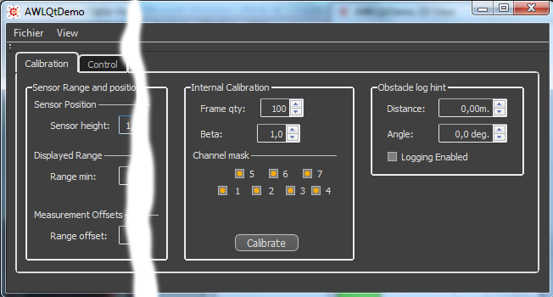

Figure 11: Calibration tab of the main window

1. Set up the mask sheet according to the type of calibration performed.
2. In the main window of the application, select the “Calibration” tab.
3. In the “Internal Calibration” section of that tab, make sure that all of the “Channel Mask” check boxes are selected (highlighted in orange).
4. In the same section, make sure that the Frame qty is set to 100 and that the beta value is at 1,0 (which are the default values for these fields).
5. Press the “Calibrate” button and wait a few seconds.

During the calibration procedure, the EV-Unit temporarily stops reporting data to the application. It resumes reporting after a few seconds (typically 1-2 seconds max).